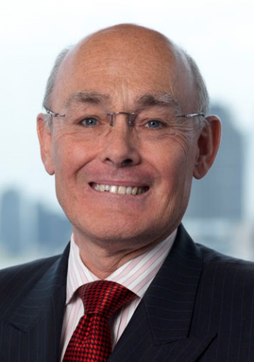  “Defends clients’ interest with the utmost integrity”  Chambers & Partners (2014)  “Really understands what his clients need, he is client-orientated. He can deliver good work whilst sticking to my brief”  Chambers & Partners (2013)  “Highly commended” Legal Business magazine Insurance Team of the Year (2013)  “Very focused on client service and user-friendly”  Chambers & Partners (2012) | CHARLES gORDON  DOB 21 aPRIL 1953. uk citizen.  Charles Gordon is a mediator and arbitrator with JAMS International. He is listed in the Legal 500 guide to mediators.  He handles a wide range of disputes including insurance and reinsurance coverage, energy, professional negligence, property, shareholder and joint venture disputes. He is appointed by a wide range of law firms in London, the UK regions and internationally. He writes on disputes resolution topics and lectures on the subject. Charles is also involved in mediation training.  Charles was a law firm partner for over 30 years. He led the International Insurance practice at DLA Piper until his retirement in 2014. He still acts a consultant to clients in the insurance and reinsurance sectors.  Charles was also, until October 2016, the litigation director of The RBoS Action Group advising on the £5 billion shareholder litigation against the Royal Bank of Scotland.  Charles is also a visiting lecturer at Queen Mary University College in London. He is a Liveryman of the Worshipful Company of Insurers and a member of the British Insurance Law Association.  He is admitted to the Bar of the Bahamas.  Charles is also a mentor with the Princes Trust.  Having advised on leading cases at all levels of the English court, Charles has consistently been recognised in Chambers & Partners and the Legal 500 guides to the legal profession.  Noted for combining a warm sense of humour with robust probing of parties’ positions, Charles is described as a “natural mediator” whose style is built on meticulous preparation and a thorough understanding of clients’ commercial positions.  RECENT MEDIATION AND ARBITRATION APPOINTMENTS  - Political Risk reinsurance dispute involving abandonment/expropriation of power generating equipment in country subject to civil war  - Wrongful trading claim against directors of insolvent UK company, part of international group. Involvement of insolvent international bank and issues arising out of Global Financial Crisis  - Dispute between US property company and international insurer. Bad Faith claim before US courts  - Contested probate and solicitors’ negligence in relation to complex international estate  - Offshore insolvency of world-wide financial services/banking group. Fraud and negligence allegations  - Allegations of fraud and negligence against London property professionals in respect of very valuable London real estate  - Product Liability claims arising from alleged serious defects in household materials leading to personal injury claims, economic loss and property damage  - Shareholder dispute over lending to leading London hotels group, disputed pre-emption rights  - Fraud alleged against financial services company by off shore trusts, insurance coverage issues  - Dispute over guarantee rights in respect of US film projects  CONTACT DETAILS  charles@gordonlaw.eu  cgordon@jamsinternational.com  +44 7968 558729  Background & Education  - Independent mediator and arbitrator with Jams International 2014 to date  - Litigation Director, RBoS Action Group January to October 2016  - Partner, Litigation, head of International Insurance, (EMEA), DLA Piper (2001–2014). Consultant from 1/5/14 to 30/4/2015  - Partner, Head of Litigation and Insolvency, Manches (1985-2001)  - Solicitor, Clifford Turner (now Clifford Chance) (1981-1985)  - Barrister, 3 Doctor Johnson's Buildings, Temple, London, EC4 (1976-1981)  - College of Law (1980)  - Inns of Court School of Law (1975-1976)  - Balliol College, Oxford (1971-1974)  - St George's College, Weybridge, Surrey (1961-1970)  Honours, Memberships and Professional Activities  - Leading international project relating to Micro Insurance in developing countries ( 2014-2015 )  - Law Works Fellow (2014- )  - Lecturer, Principles of Legal Drafting, Dar Es Salaam Law School, Tanzania (2014)  - Member Law Society EU Committee (2014- )  - Ombudsman for Food Supply Chain Initiative ( 2014- 2015 )  - Visiting Lecturer, Queen Mary University College, London (2014- )  - Report into Judicial Standards in Bangladesh (2013)  - European Commission Expert Group - EU Insurance Law (2013)  - Liveryman, Worshipful Company of Insurers (2013)  - Member Civil Mediation Council (2012 - present)  - Chairman of Governors at New Beacon School (2008-2012)  - Arbitrator (1990 to date)  - Accredited Mediator (1990)  - Founder Special Care Baby Charity, Farnborough Hospital, Kent (1987)  - Licensed Insolvency Practitioner (!987)

